# Overview of silent sound technology

* The Silent sound technology is a perfect solution for those people who have lost voice but wish to speak on mobile phones.
* This technology helps to detect every lip movement and converts the electrical pulses into sounds signals and sends those signals avoiding the surrounding noise which may cause disturbance.
* This is going to be a good solution for those who have lost their intensity to speak.
* The main aim of ‘Silent Sound’ technology is to notice every movement of the lips and convert them into sound so that the information can be transferred in audio form, which could allow people to make silent calls without bothering about other people. Rather than making any sound, your handset will transfer the movements your mouth makes which will measure the muscle activity with the help of that handset then convert this into audio speech that the person can hear on the other end of the call on phone. So, it reads your lips.
* This new technology will be very helpful whenever a person loses his. Voice while speaking and it also allows people to make silent calls without disturbing others.
* This technology can also be used in the military sectors for sharing secret matters with other people. It provides a PIN number which can be given to a trusted person so that the listener can hear a clear voice on the other end.

# Introduction

* Silence is the best answer for all the situations …even your mobile understands!
* The word Cell Phone has become greatest buzz word in Cellular Communication industry.
* There are lots and lots of technology that tries to reduce the Noise pollution and make the environment a better place to live in.
* I will tell about a new technology known as Silent Sound Technology that will put an end to Noise pollution.
* You are in a movie theatre or noisy restaurant or a bus etc where there is lot of noise around is big issue while talking on a mobile phone. But in the future this problem is eliminated with ”silent sounds”, a new technology unveiled at the CeBIT fair on Tuesday that transforms lip movements into a computer-generated voice for the listener at the other end of the phone.
* It is a technology that helps you to transmit information without using your vocal cords. This technology aims to notice lip movements & transform them into a computer generated sound that can be transmitted over a phone. Hence person on other end of phone receives the information in audio.
* In the 2010 CeBIT's "future park", a concept "Silent Sound" Technology demonstrated which aims to notice every movement of the lips and transform them into sounds, which could help people who lose voices to speak, and allow people to make silent calls without bothering others.
* The device, developed by the Karlsruhe Institute of Technology (KIT), uses electromyography, monitoring tiny muscular movements that occur when we speak and converting them into electrical pulses that can then be turned into speech, without a sound uttered.
* ‘Silent Sound’ technology aims to notice every movements of the lips and transform them into sounds, which could help people who lose voices to speak, and allow people to make silent calls without bothering others. Rather than making any sounds, your handset would decipher the movements your mouth makes by measuring muscle activity, then convert this into speech that the person on the other end of the call can hear. So, basically, it reads your lips.

### “We currently use electrodes which are glued to the skin. In the future, such electrodes might for example by incorporated into cell phones,”

**Said Michael Wand, from the KIT.**



Figure 1**.**-common people talking at same place without isturbance

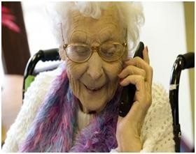

Figure:2 Silent sound technology can help in this situation. Old woman talking on phone and the listener is hearing itclearly.



Figure:3 Silent sound technology can happen in this scenario. Student making a phone call in student conference withoutmaking noise.

* + The technology opens up a host of applications, from helping people who have lost their voice due to illness or accident to telling a trusted friend your PIN number over the phone without anyone eavesdropping — assuming no lip-readers are around.
  + The technology can also turn you into an instant polyglot. Because the electrical pulses are universal, they can be immediately transformed into the language of the user’s choice.
  + “Native speakers can silently utter a sentence in their language, and the receivers hear the translated sentence in their language. It appears as if the native speaker produced speech in a foreign language,” said Wand.
  + The translation technology works for languages like English, French and German, but for languages like Chinese, where different tones can hold many different meanings, poses a problem, he added.
  + Noisy people in your office? Not anymore. “We are also working on technology to be used in an office environment,” the KIT scientist told AFP.
  + The engineers have got the device working to 99 percent efficiency, so the mechanical voice at the other end of the phone gets one word in 100 wrong, explained Wand.
  + “But we’re working to overcome the remaining technical difficulties. In five, maybe ten years, this will be useable, everyday technology,” he said.

# History

* + The first documented experiments dealing with EMG started with Francesco Redi’s works in 1666. Redi discovered a highly specialized muscle of the electric ray fish (Electric Eel) generated electricity. By 1773, Walsh had been able to demonstrate that the Eel fish’s muscle tissue could generate a spark of electricity. In 1792, a publication entitled *De Viribus Electricitatis in Motu Musculari Commentarius* appeared, written by Luigi Galvani, in which the author demonstrated that electricity could initiate muscle contractions. Six decades later, in 1849, Dubois-Raymond discovered that it was also possible to record electrical activity during a voluntary muscle contraction. The first actual recording of this activity was made by Marey in 1890, who also introduced the term electromyography.
  + In 1922, Gasser and Erlanger used an oscilloscope to show the electrical signals from muscles. Because of the stochastic nature of the myoelectric signal, only rough information could be obtained from its observation.
  + The capability of detecting electromyographic signals improved steadily from the 1930s through the 1950s, and researchers began to use improved electrodes more widely for the study of muscles. Clinical use of surface EMG (sEMG) for the treatment of more specific disorders began in the 1960s. Hardyck and his researchers were the first (1966) practitioners to use sEMG. In the early 1980s, Cram and Steger introduced a clinical method for scanning a variety of muscles using an EMG sensing device.
  + It is not until the middle of the 1980s that integration techniques in electrodes had sufficiently advanced to allow batch production of the required small and lightweight instrumentation and amplifiers. At present, a number of suitable amplifiers are commercially available. In the early 1980s, cables that produced signals in the desired microvolt range became available. Recent research has resulted in a better understanding of the properties of surface EMG recording. Surface electromyography is increasingly used for recording from superficial muscles in clinical or kinesiological protocols, where intramuscular electrodes are used for investigating deep muscles or localized muscle activity.

# Structure and working

## Process of speaking

* The air passes through the larynx and the tongue and the words are formed with the help of the articulator muscles in the mouth and the jaw.
* The articulator muscles are activated irrespective of the fact that jo air passes through them or not.
* The weak signals are sent from the brain to the speech muscle.
* These signals are collectively known as the electromyograms.

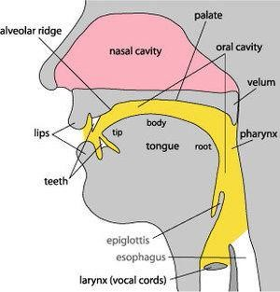

Figure:4 Speaking Process in human body

## NEED FOR SILENT SOUND

Silent Sound Technology will put an end to embarrassed situation such as-

* + - An person answering his silent, but vibrating cell phone in a meeting, lecture or performance, and whispering loudly, ‘I can’t talk to you right now’.
    - In the case of an urgent call, apologetically rushing out of the room in order to answer or call the person back.
* When you add lawnmowers, snow blowers, leaf blowers, jack hammers, jet engines, transport trucks, and horns and buzzers of all types and descriptions you have a wall of constant noise and irritation.
* Even when watching a television program at a reasonable volume level you are blown out of your chair when a commercial comes on at the decibel level of a jet.
* The technology opens up a host of applications, from helping people who have lost their voice due to illness or accident to telling a trusted friend your PIN number over the phone without anyone eavesdropping — assuming no lip-readers are around.
* Native speakers can silently utter a sentence in their language, and the receivers hear the translated sentence in their language.
* It appears as if the native speaker produced speech in a foreign language.

## OBJECTIVE:

Aim of this research work is to analyze and understand -every movement of the lips and facial expressions then transform them into text and audio output: Capturing the video using an integrated camera and process it based on histogram equalization for gray scale mode selection or normal mode. Skin segmentation and morphological operation helps to locate facial features in the interior of the face and color coded perimeter with fitting points on the contour of the lip. Obtained multi image montage of lip will be converted to an average threshold value that helps to set the matching parameters to a very close value of other known templates in the database so as to test the feedback provided by the system will be a match or a miss-match to obtain text and sound output.

## ORIGINATION

* + - Humans are capable of producing and understanding whispere speech in quiet environments at remarkably low signal levels.
    - Most people can also understand a few unspoken words by lip-reading The idea of interpreting silent speech electronically or with a computer has been around for a long time, and was popularized in the 1968 Stanley Kubrick science-fiction film **‘‘2001 – A Space Odyssey ”** A major focal point was the **DARPA Advanced Speech Encoding Program (ASE )** of the early 2000’s, which funded research on low bit rate speech synthesis ‘‘with acceptable intelligibility, quality , and aural speaker recognizability in acoustically harsh environments”,

## METHODS

Silent Sound Technology is processed through some ways or methods. They are

* Electromyograpy(EMG)
* Image Processing

## Image Processing

* The simplest form of digital image processing converts the digital data tape into a film image with minimal corrections and calibrations.
* Then large mainframe computers are employed for sophisticated interactive manipulation of the data.
* In the present context, overhead prospective are employed to analyze the picture.
* In electrical engineering and computer science, image processing is any form of signal processing for which the input is an image, such as a photograph or video frame; the output of image processing may be either an image or, a set of characteristics or parameters related to the image. Most image-processing techniques involve treating the image as a two-dimensional signal and applying standard signal-processing techniques to it.
* Image processing usually refers to digital image processing, but optical and analog image processing also are possible.
* This article is about general techniques that apply to all of them. The acquisition of images (producing the input image in the first place) is referred to as imaging.
* Image processing is a physical process used to convert an image signal into a physical image.The image signal can be either digital or analog.
* The actual output itself can be an actual physical image or the characteristics of an image.
* The most common type of image processing is photography.
* In this process, an image is captured using a camera to create a digital or analog image.
* In order to produce a physical picture, the image is processed using the appropriate technology based on the input source type.
* In digital photography, the image is stored as a computer file. This file is translated using photographic software to generate an actual image.
* The colours, shading, and nuances are all captured at the time the photograph is taken the software translates this information into an image.
* When creating images using analog photography, the image is burned into a film using a chemical reaction triggered by controlled exposure to light.
* The image is processed in a darkroom, using special chemicals to create the actual image.
* This process is decreasing in popularity due to the advent of digital photography, which requires less effort and special training to product images.
* In addition to photography, there are a wide range of other image processing operations
* The field of digital imaging has created a whole range of new applications and tools that were previously impossible.
* Face recognition software, medical image processing and remote sensing are all possible due to the development of digital image processing.
* Specialized computer programs are used to enhance and correct images. These programs apply algorithms to the actual data and are able to reduce signal distortion, clarify fuzzy images and add light to an underexposed image.
* Image processing techniques were first developed in 1960 through the collaboration of a wide range of scientists and academics.
* The main focus of their work was to develop medical imaging, character recognition and create high quality images at the microscopic level.
* During this period, equipment and processing costs were prohibitively high.
* The financial constraints had a serious impact on the depth and breadth of technology development that could be done.
* By the 1970s, computing equipment costs had dropped substantially making digital image processing more realistic. Film and software companies invested significant funds into the development and enhancement of image processing, creating a new industry.
* There are three major benefits to digital image processing.
* The consistent high quality of the image, the low cost of processing and the ability to manipulate all aspects of the process are all great benefits.
* As long as computer processing speed continues to increase while the cost of storage memory continues to drop, the field of image processing will grow.

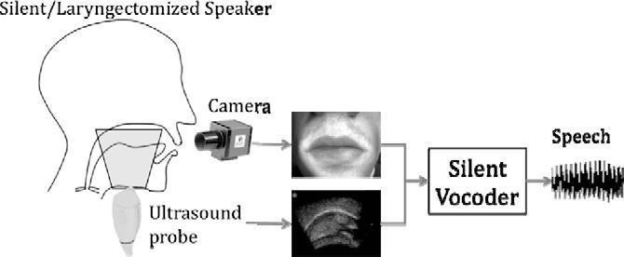Figure 5: silent sound interface using image processing

## ARCHITECTURE PROCESS MODEL AND WORKING METHOD

To proceed with this research work, the Process Model assumed is Iterative Process Model since it is more adaptable for this work. Once the face detection and mouth region detection is achieved, speech analysis can be performed with the use of lip motion feature strategies and emotional expression with the use of other facial parts.

If efficiency with identification technique is not proper then the threshold value falls out of the defined unique index value and retrial has to be made. Those are one of the main reasons to choose the Iterative Process Fig. shows the overall architecture of the process model and its working methodology.

As the image is captured by a high resolution camera, the image can be processed as normal or greyscale color mode/or saved as Mpeg, Avi, Flv etc. for customization. Region of Interest (ROI) image is segmented from which Facial features like Mouth, Nose & Eyes are detected.

As the lip contour is initiated accurately, the separated lip shape is morphologically prepared and corners are fitted by the key focuses like left/right and upper/bring down corners with centroid . Getting the lip form in resulting outlines and the lip development is totally followed. A multi outline montage in a solitary question picture montage is constructed and a database is made for it and got include like eyes and nose vector in the database.

The obscure formats of a client are then contrasted and the current layouts in the database. In the event that the edges breeze through the edge test with the known and obscure formats, in view of prepared and tried file esteem/trials the client can get a content yield and later a sound yield

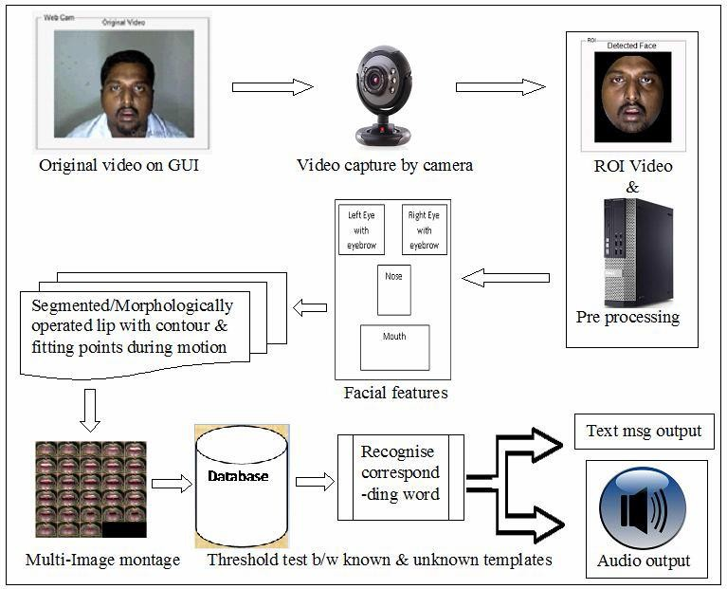

Figure.6 .Process model architecture and its workingmethodology

## SKIN SEGMENTATION AND MORPHOLOGY

One the important step in face feature extraction process is skin segmentation. As we know human face varies from person to person, so the race, gender, age and other physical characteristics of an individual have to be considered.

The partition is based on the shading distinction between the skin and non-skin districts . The proficiency of the shading division of a human face relies upon the shading space that is chosen. We utilized the finding by Yang and Waibel who noticed that the skin shades of various individuals are firmly assembled in the standardized R-G shading plane. So a portion of the seed pixels are taken from the face territory acquired the standardized R-G spread and arranged the pixels that were sufficiently close to this spread as having a place with the face.

In this stage we distinguish confront area from input video, separating it into outlines either in gray scale or shading mode. To extricate confront area we perform lighting remuneration on picture, at that point separate skin district and expel all the loud information from picture locale. Discovering skin shading hinders from the picture and after that check con front measures of the picture. In lighting pay we standardize the power of the picture, while separating skin district at that point apply edge for the chrominance and after that select the pixels that are fulfilling the limit to discover the shading squares. The skin shading pieces are distinguished in view of the measure properties of picture districts in picture. Stature and width proportion is registered and insignificant face measurement limitation is actualized. Product the present district, presence and restriction of face at that point register vertical histogram. Because of skin division the inside openings that are made on the face area are morphologically prepared.

## RESULT

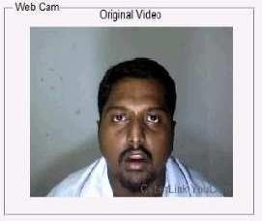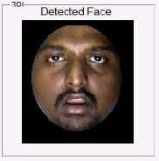

Fig.7 Live image Fig.8 ROI

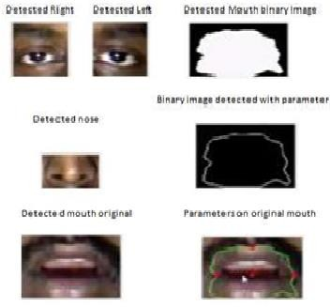

Fig .9. Facial features detected live image for Silent character

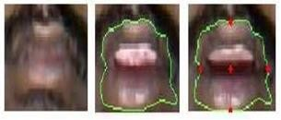

Fig.10.Lip during motion with perimetercontour & key points

* Analysis of remotely sensed data is done using various image processing techniques and methods
  1. Analog Image processing
  2. Digital Image Processing

## Analog Image processing

Analog processing techniques are applied to hard copy data such as photographs or printouts.Image analysis in visual techniques adopts certain elements of interpretation, which are as follow:

* + Analog processing techniques are applied to hard copy data such as photographs or printouts.
  + It adopts certain elements of interpretation, such as primary element, spatial arrangement etc.
  + With the combination of multi-concept of examining remotely sensed data it allows us to make a verdict not only as to what an object is but also its importance.
  + Apart from these it also includes optical photogrammetric techniques allowing for precise measurement of the height, width, location, etc. of an object.
  + The use of these fundamental elements of depends not only on the area being studied, but the knowledge of the analyst has of the study area.
  + For example the texture of an object is also very useful in distinguishing objects that may appear the same if the judging solely on tone (i.e., water and tree canopy, may have the same mean brightness values, but their texture is much different.
  + Association is a very powerful image analysis tool when coupled with the general knowledge of the site.
  + Thus we are adept at applying collateral data and personal knowledge to the task of image processing.
  + With the combination of multi-concept of examining remotely sensed data in multispectral, multi temporal, multi scales and in conjunction with multidisciplinary, allows us to make a verdict not only as to what an object is but also its importance.
  + Apart from these analog images processing techniques also includes optical photogrammetric techniques allowing for precise measurement of the height,width, location, etc. of an object.

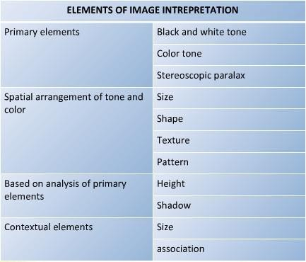

Table: 1 Element of image interpretation

* + Image processing usually refers to digital image processing, but optical and analog image processing also are possible. This article is about general techniques that apply to all of them. The acquisition of images (producing the input image in the first place) is referred to a simaging.
  + Image processing is a physical process used to convert an image signal into a physical image. The image signal can be either digital or analog.
  + The actual output itself can be an actual physical image or the characteristics of an image. The most common type of image processing is photography.
  + In this process, an image is captured using a camera to create a digital or analog image. In order to produce a physical picture, the image is processed using the appropriate technology based on the input source type.

## Digital image processing

* + Digital Image Processing involves a collection of techniques for the manipulation of digital images by computers.
  + Digital Image Processing involves a collection of techniques for the manipulation of digital images by computers. Digital image processing is the use of computer algorithms to perform image processing on digital images.
  + As a subcategory or field of digital signal processing, digital image processing has many advantages over analog image processing.
  + It allows a much wider range of algorithms to be applied to the input data and can avoid problems such as the build-up of noise and signal distortion during processing.
  + In a most generalized way, a digital image is an array of numbers depicting spatial distribution of a certain field parameters (such as reflectivity of EM radiation, emissivity, temperature or some geophysical or topographical elevation. Digital image consists of discrete picture elements called pixels.
  + Associated with each pixel is a number represented as DN (Digital Number) that depicts the average radiance of relatively small area within a scene. The range of DN values being normally 0 to 255. The size of this area effects the reproduction of details within the scene. As the pixel size is reduced more scene detail is preserved.
  + Remote sensing images are recorded in digital forms and then processed by the computers to produce images for interpretation purposes. Images are available in two forms -photographic film form and digital form. Variations in the scene characteristics are represented as variations in brightness on photographic films.
  + A particular part of scene reflecting more energy will appear bright while a different part of the same scene that reflecting less energy will appear black. Digital image consists of discrete picture elements called pixels. Associated with each pixel is a number represented as DN (Digital Number) that depicts the average radiance of relatively small area within a scene. The size of this area effects the reproduction of details within the scene.
  + As the pixel size is reduced more scene detail is preserved in digital representation. Digital processing is used in a variety of applications. The different types of digital processing include image processing, audio processing, video processing, signal processing, and data processing. In the most basic terms, digital processing refers to any manipulation of electronic data to produce a specific effect.
  + In a most generalized way, a digital image is an array of numbers depicting spatial distribution of a certain field parameters (such as reflectivity of EM radiation, emissivity, temperature or some geophysical or topographical elevation. Digital image consists of discrete picture elements called pixels.
  + Associated with each pixel is a number represented as DN (Digital Number) that depicts the average radiance of relatively small area within a scene. The range of DN values being normally 0 to 255. The size of this area effects the reproduction of details within the scene. As the pixel size is reduced more scene detail is preserved in digital representation.
  + Remote sensing images are recorded in digital forms and then processed by the computers to produce images for interpretation purposes. Images are available in two forms – photographic film form and digital form. Variations in the scene characteristics are represented as variations in brightness on photographic films. A particular part of scene reflecting more energy will appear bright while a different part of the same scene that reflecting less energy will appear black. Digital image consists of discrete picture elements called pixels.
  + Associated with each pixel is a number represented as DN (Digital Number) that depicts the average radiance of relatively small area within a scene. The size of this area effects there production of details within the scene. As the pixel size is reduced more scene detail is preserved in digital representation. Data Formats For Digital Satellite Imagery Digital data from the various satellite systems supplied to the user in the form of computer readable tapes or CD-ROM.
  + As no worldwide standard for the storage and transfer of remotely sensed data has been agreed upon, though the CEOS (Committee on Earth Observation Satellites) format is becoming accepted as the standard.
  + Digital remote sensing data are often organized using one of the three common formats used to organize image data. For an instance an image consisting of four spectral channels, which can be visualized as four superimposed images, with corresponding pixels in one band registering exactly to those in the other bands. These common formats are:
    - Band Interleaved by Pixel (BIP)
    - Band Interleaved by Line (BIL)
    - Band Sequential (BQ)
  + Digital image analysis is usually conducted using Raster data structures - each image is treated as an array of values. It offers advantages for manipulation of pixel values by image processing system, as it is easy to find and locate pixels and their values.
  + Disadvantages become apparent when one needs to represent the array of pixels as discrete patches or regions, whereas Vector data structures use polygonal patches and their boundaries as fundamental units for analysis and manipulation.
  + The vector format is not appropriate to digital analysis of remotely sensed data.

## Image Resolution

* + Resolution can be defined as "the ability of an imaging system to record fine details in a distinguishable manner". A working knowledge of resolution is essential for understanding both practical and conceptual details of remote sensing. Along with the actual positioning of spectral bands, they are of paramount importance in determining the suitability of remotely sensed data for a given applications.
  + The major characteristics of imaging remote sensing instrument operating in the visible and infrared spectral region are described in terms as follow:
    - Spectral resolution
    - Radiometric resolution
    - Spatial resolution
    - Temporal resolution

## Spectral resolution

* + Spectral Resolution refers to the width of the spectral bands. As different material on the earth surface exhibit different spectral reflectance and emissivity. These spectra characteristics define the spectral position and spectral sensitivity in order to distinguish materials. There is a trade off between spectral resolution and signal to noise.
  + The use of well-chosen and sufficiently numerous spectral bands is a necessity, therefore, if different targets are to be successfully identified on remotely sensed images.

## Radiometric resolution

* + Radiometric Resolution or radiometric sensitivity refers to the number of digital levels used to express the data collected by the sensor.
  + It is commonly expressed as the number of bits (binary digits) needs to store the maximum level. For example Land sat TM data are quantized to 256 levels (equivalent to 8 bits). Here also there is a tradeoff between radiometric resolution and signal to noise.
  + There is no point in having a step size less than the noise level in the data. A low- quality instrument with a high noise level would necessarily, therefore, have a lower radiometric resolution compared with a high-quality, high signal-to-noise-ratio instrument. Also higher radiometric resolution may conflict with data storage and transmission rates.

## Spatial resolution

* + Spatial Resolution of an imaging system is defines through various criteria, the geometric properties of the imaging system, the ability to distinguish between point targets, the ability to measure the periodicity of repetitive targets ability to measure the spectral properties of small targets. The most commonly quoted quantity is the instantaneous field of view (IFOV), which is the angle subtended by the geometrical projection of single detector element to the Earth's surface.
  + It may also be given as the distance, D measured along the ground, in which case, IFOV is clearly dependent on sensor height, from the relation: D = h*b, where h is the

height and b is the angular IFOV in radians. An alternative measure of the IFOV is based on the PSF, e.g., the width of the PDF at half its maximum value.

* + A problem with IFOV definition, however, is that it is a purely geometric definition and does not take into account spectral properties of the target. The effective resolution element (ERE) has been defined as "the size of an area for which a single radiance value can be assigned with reasonable assurance that the response is within 5% of the value representing the actual relative radiance". Being based on actual image data, this quantity may be more useful in some situations than the IFOV. Other methods of defining the spatial resolving power of a sensor are based on the ability of the device to distinguish between specified targets. Of the concerns the ratio of the modulation of the image to that of the real target.

Modulation, M, is defined as:

M = Emax -Emin / Emax + Emin

Where Emax and Emin are the maximum and minimum radiance values recorded over the image.

## Temporal resolution

* + It‘s refers to the frequency with which images of a given geographic location can be acquired. Satellites not only offer the best chances of frequent data coverage but also of regular coverage. The temporal resolution is determined by orbital characteristics and swath width, the width of the imaged area. Swath width is given by 2htan (FOV/2) where h is the altitude of the sensor, and FOV is the angular field of view of the sensor. It contains some flaws. To overcome the flaws and deficiencies in order to get the originality of the data, it needs to undergo several steps of processing.
  + Since images are defined over two dimensions (perhaps more) digital image processing may be modeled in the form of Multidimensional Systems.
  + It contains some flaws. To overcome the flaws and deficiencies in order to get the originality of the data, it needs to undergo several steps of processing.
  + Digital Image Processing undergoes three general steps:

1. Pre-processing Display
2. Enhancement
3. Information extraction

The Flow diagram that explains the steps that takes place during the Digital Image Processing is shown below:

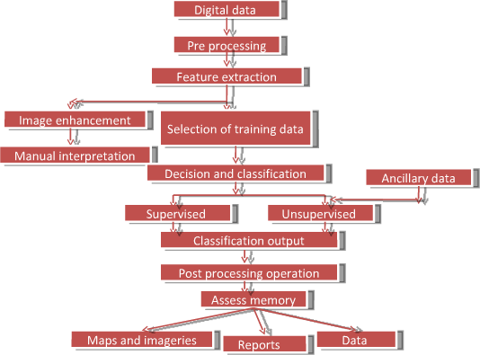

Figure 11 :Digital pre-processing

## Pre-Processing :

* + Pre-processing consists of those operations that prepare data for subsequent analysis that attempts to correct or compensate for systematic errors.
  + Then analyst may use feature extraction to reduce the dimensionality of the data.
  + Thus feature extraction is the process of isolating the most useful components of the data for further study while discarding the less useful aspects.
  + It reduces the number of variables that must be examined, thereby saving time and resources.
* Pre-processing consists of those operations that prepare data for subsequent analysis that attempts to correct or compensate for systematic errors.
* The digital imageries are subjected to several corrections such as geometric, radiometric and atmospheric, though all this correction might not be necessarily is applied in all cases.
* These errors are systematic and can be removed before they reach the user. The investigator should decide which pre-processing techniques are relevant on the basis of the nature of the information to be extracted from remotely sensed data. After pre- processing is complete, the analyst may use feature extraction to reduce the dimensionality of the data.
* Thus feature extraction is the process of isolating the most useful components of the data for further study while discarding the less useful aspects (errors, noise etc). Feature extraction reduces the number of variables that must be examined, thereby saving time and resources.

## Image Enhancement

* + Improves the interpretability of the image by increasing apparent contrast among various features in the scene.
  + The enhancement techniques depend upon two factors mainly
  + The digital data (i.e. with spectral bands and resolution)
  + The objectives of interpretation
  + Common enhancements include image reduction, image rectification, image magnification, contrast adjustments, principal component analysis texture transformation and so on.

Image Enhancement operations are carried out to improve the interpretability of the image by increasing apparent contrast among various features in the scene. The enhancement techniques depend upon two factors mainly.

As an image enhancement technique often drastically alters the original numeric data, it is normally used only for visual (manual) interpretation and not for further numeric analysis.

Common enhancements include image reduction, image rectification, image magnification, transect extraction, contrast adjustments, band rationing, spatial filtering, Fourier transformations, principal component analysis and texture transformation

### INFORMATION EXTRACTION

* + In Information Extraction the remotely sensed data is subjected to quantitative analysis to assign individual pixels to specific classes. It is then classified.
  + It is necessary to evaluate its accuracy by comparing the categories on the classified images with the areas of known identity on the ground.
  + The final result of the analysis consists of maps (or images), data and a report. Then these are converted to corresponding signals.

Information Extraction is the last step toward the final output of the image analysis. After pre- processing and image enhancement the remotely sensed data is subjected to quantitative analysis to assign individual pixels to specific classes. Classification of the image is based on the known and unknown identity to classify the remainder of the image consisting of those

pixels of unknown identity. After classification is complete, it is necessary to evaluate its accuracy by comparing the categories on the classified images with the areas of known identity on the ground. The final result of the analysis consists of maps (or images), data and a report.

These three components of the result provide the user with full information concerning the source data, the method of analysis and the outcome and its reliability. Pre-Processing of the Remotely Sensed Images When remotely sensed data is received from the imaging sensors on the satellite platforms it contains flaws and deficiencies. Pre-processing refers to those operations that are preliminary to the main analysis.

Pre-processing includes a wide range of operations from the very simple to extremes of abstractness and complexity. These categorized as follow:

* + - Feature Extraction
    - Radiometric Corrections
    - Geometric Corrections
    - Atmospheric Correction
* The techniques involved in removal of unwanted and distracting elements such as image/system noise, atmospheric interference and sensor motion from an image data occurred due to limitations in the sensing of signal digitization, or data recording or transmission process.
* Removal of these effects from the digital data are said to be "restored" to their correct or original condition, although we can, of course never know what are the correct values might be and must always remember that attempts to correct data what may themselves introduce errors. Thus image restoration includes the efforts to correct for both radiometric and geometric errors.

## FEATURE EXTRACTION

Feature Extraction does not mean geographical features visible on the image but rather "statistical" characteristics of image data like individual bands or combination of band values that carry information concerning systematic variation within the scene. Thus in a multispectral data it helps in portraying the necessity elements of the image. It also reduces the number of spectral bands that has to be analyzed. After the feature extraction is complete the analyst can work with the desired channels or bands, but in turn the individual bandwidths are more potent for information. Finally such a pre-processing increases the speed and reduces the cost of analysis.

## IMAGE ENHANCEMENT TECHNIQUE

* + Image Enhancement techniques are instigated for making satellite imageries more informative and helping to achieve the goal of image interpretation. The term enhancement is used to mean the alteration of the appearance of an image in such a way that the information contained in that image is more readily interpreted visually in terms of a particular need.
  + The image enhancement techniques are applied either to single-band images or separately to the individual bands of a multiband image set

These techniques can be categorized into two:

* + - Spectral Enhancement Techniques
    - Multi-Spectral Enhancement Techniques

### Spectral Enhancement Techniques

Density Slicing is the mapping of a range of contiguous grey levels of a single band image to a point in the RGB color cube. The DNs of a given band are "sliced" into distinct classes. For example, for band 4 of a TM 8 bit image, we might divide the 0-255 continuous range into discrete intervals of 0-63, 64-127, 128-191 and 192-255. These four classes are displayed as four different grey levels. This kind of density slicing is often used in displaying temperature maps.

## CONTRAST STRETCHING

The operating or dynamic , ranges of remote sensors are often designed with a variety of eventual data applications. For example for any particular area that is being imaged it is unlikely that the full dynamic range of sensor will be used and the corresponding image is dull and lacking in contrast or over bright.

Landsat TM images can end up being used to study deserts, ice sheets, oceans, forests etc., requiring relatively low gain sensors to cope with the widely varying radiances upwelling from dark, bright , hot and cold targets. Consequently, it is unlikely that the full radiometric range of brand is utilised in an image of a particular area. The result is an image lacking in contrast - but by remapping the DN distribution to the full display capabilities of an image processing system, we can recover a beautiful image. Contrast Stretching can be displayed in three categories

## LINEAR CONTRAST STRETCH

This technique involves the translation of the image pixel values from the observed range DNmin to DNmax to the full range of the display device(generally 0-255, which is the range of values representable in an 8bit display devices)This technique can be applied to a single band, grey-scale image, where the image data are mapped to the display via all three colours LUTs.

* + It is not necessary to stretch between DNmax and DNmin - Inflection points for a linear contrast stretch from the 5th and 95th percentiles, or ± 2 standard deviations from the mean (for instance) of the histogram, or to cover the class of land cover of interest (e.g. water at expense of land or vice versa).
  + It is also straightforward to have more than two inflection points in a linear stretch, yielding a piecewise linear stretch.

### HISTOGRAM EQUALISATION

* + The underlying principle of histogram equalisation is straightforward and simple, it is assumed that each level in the displayed image should contain an approximately equal number of pixel values, so that the histogram of these displayed values is almost uniform (though not all 256 classes are necessarily occupied).
  + The objective of the histogram equalisation is to spread the range of pixel values present in the input image over the full range of the display device.

## GAUSSIANSTRETCH

This method of contrast enhancement is base upon the histogram of the pixel values is called a Gaussian stretch because it involves the fitting of the observed histogram to a normal or Gaussian histogram. It is defined as follow:

F(x) = (a/p)0.5 exp(-ax2)

## Multi-Spectral Enhancement Techniques Image Arithmetic Operations

* + The operations of addition, subtraction, multiplication and division are performed on two or more co-registered images of the same geographical area. These techniques are applied to images from separate spectral bands from single multispectral data set or they may be individual bands from image data sets that have been collected at different dates. More

complicated algebra is sometimes encountered in derivation of sea-surface temperature from multispectral thermal infrared data (so called split-window and multichannel techniques)

* + Addition of images is generally carried out to give dynamic range of image that equals the input images.
  + Band Subtraction Operation on images is sometimes carried out to co- register scenes of the same area acquired at different times for change

detection

* + Multiplication of images normally involves the use of a single'real' image and binary image made up of ones and zeros.
  + Band Ratioing or Division of images is probably the most common arithmetic operation that is most widely applied to images in geological, ecological and agricultural applications of remote sensing.
  + Ratio Images are enhancements resulting from the division of DN values of one spectral band by corresponding DN of another band. One instigation for this is to iron out differences in scene illumination due to cloud or topographic shadow. Ratio images also bring out spectral variation in different target materials.
  + Multiple ratio image can be used to drive red, green and blue monitor guns for color images. Interpretation of ratio images must consider that they are "intensity blind", i.e, dissimilar materials with different absolute reflectances but similar relative reflectances in the two or more utilised bands will look the same in the output image.

## Principal Component Analysis

* + Spectrally adjacent bands in a multispectral remotely sensed image are often highly correlated.
  + Multiband visible/near-infrared images of vegetated areas will show negative correlations between the near-infrared and visible red bands and positive correlations among the visible bands because the spectral characteristics of vegetation are such that as the vigour or greenness of the vegetation increases the red reflectance diminishes and the near-infrared reflectance increases. Thus presence of correlations among the bands of a multispectral image implies that there is redundancy in the data and *Principal Component Analysis* aims at removing this redundancy
  + Principal Components Analysis (PCA) is related to another statistical technique called factor analysis and can be used to transform a set of image bands such that the new bands (called principal components) are uncorrelated with one another and are ordered in terms of the amount of image variation they explain.
  + The components are thus a statistical abstraction of the variability inherent in the original band set.
  + To transform the original data onto the new principal component axes, transformation coefficients (eigen values and eigen vectors) are obtained that are further applied in alinear fashion to the original pixel values.
  + This linear transformation is derived from the covariance matrix of the original data set. These transformation coefficients describe the lengths and directions of the principal axes.
  + Such transformations are generally applied either as an enhancement operation, or prior to classification of data.
  + In the context of PCA, information means variance or scatter about the mean. Multispectral data generally have a dimensionality that is less than the number of spectral bands.
  + The purpose of PCA is to define the dimensionality and to fix the coefficients that specify the set of axes, which point in the directions of greatest variability. The bands of PCA are often more interpretable than the source data.

## Decorrelation Stretch

* + Principal Components can be stretched and transformed back into RGB colours - a process known as decorrelation stretching.
  + If the data are transformed into principal components space and are stretched within this space, then the three bands making up the RGB color composite images are subjected to stretched will be at the right angles to each other.
  + In RGB space the three-color components are likely to be correlated, so the effects of stretching are not independent for each color. The result of decorrelation stretch is generally an improvement in the range of intensities and saturations for each color with the hue remaining unaltered.
  + Decorrelation Stretch, like principal component analysis can be based on the covariance matrix or the correlation matrix. The resultant value of the decorrelation stretch is also a function of the nature of the image to which it is applied. The method seems to work best on images of semi-arid areas and it seems to work least well where the area is covered by the imaging includes both land and sea.

## CANONICAL COMPONENTS

PCA is appropriate when little prior information about the scene is available. Canonical component analysis, also referred to as multiple discriminate analysis, may be appropriate when information about particular features of interest is available. Canonical component axes are located to maximize the severability of different user-defined feature types.

Hue, Saturation and Intensity (HIS) Transform:

Hues is generated by mixing red, green and blue light are characterized by coordinates on the red, green and blue axes of the color cube. The hue-saturation- intensity hex cone model, where he is the dominant wavelength of the perceived color represented by angular position around the top of a hex cone, saturation or purity is given by distance from the central , vertical axis of the hex cone and intensity or value is represented by distance above the apex of the hex cone. Hue is what we perceive as color .

Saturation is the degree of purity of the color and may be considered to be the amount of white mixed in with the color. It is sometimes useful to convert from RGB colour cube coordinates to the hue, saturation and intensity transform is useful in two ways: first as method of image enhancement and secondly as a means of combining co-registered images from different sources.

The advantage of the HIS system is that it is a more precise representation of human color vision than the RGB system. This transformation has been quite useful for geological applications.

## Fourier Transformation:

The Fourier Transform operates on a single -band image. Its purpose is to break down the image into its scale components, which are defined to be sinusoidal waves with varying amplitudes, frequencies and directions. The coordinates of two- dimensional space are expressed in terms of frequency (cycles per basic interval). The function of Fourier Transform is to convert a single-band image from its spatial domain representation to the equivalent frequency-domain representation and vice- versa.

The idea underlying the Fourier Transform is that the grey-scale value forming a single-band image can be viewed as a three-dimensional intensity surface, with the rows and columns defining two axes and the grey-level value at each pixel giving the third (z)dimension. The Fourier Transform thus provides details of the frequency of each of the scale components of the image.

* + Another way to obtain direct information on the vocal tract configuration is via imaging technique. Ultrasound imagery is a non-invasive and clinically safe procedure which makes the most possible real-time visualization of one of the important articulators of speech production system- the tongue.

## ULTRASOUND

* + It is a local oscillating sound pressure wave having frequency greater than upper limit of human hearing range.

Ultrasound is thus not separated from ‘normal’ (audible) sound by difference in physical properties; only by fact humans cannot hear it. Although this limit varies from person to person, it is approximately 20 KHz. In healthy adults. Ultra sound devices operate with frequencies from 20 KHz to several gigahertzes

•

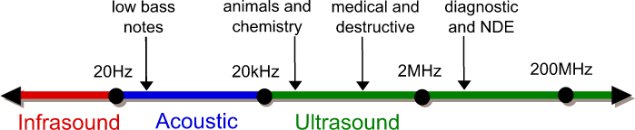

**Figure: 12 Range of Sound signals**

## SILENT SOUND INTERFACE (SSI) PROCEDURE

* + Silent Sound Interface consists of ultrasound transducer (probe), high resolution opticalcamera, lip reader, silent vcoder as shown in Fig. 6
  + Ultrasound transducer (probe) is placed beneath of the chin, can provide partial view of thetongue surface.

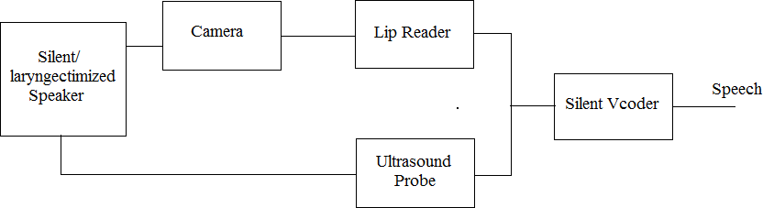

Figure 13 : Silent Sound Interface using Image Processing

* + Ultrasound device is coupled with standard optical camera as shown in fig.7 is used to capture tongue and lip movements. Because of its non-invasive property, clinically safety andgood resolution.
  + The captured images of lip and tongue movement are given to lip reader.
  + Lip reader detects the lip and tongue movements by comparing the earlier stored images of the spoken words with the present images of lip and tongue movement.
  + Where there is match in images of lip and tongue movements it generates a visual speech signal.
  + The generated visual speech signals are given to silent vcoder. It consists of an HMM based visuo-phonetic decoder, audio visual selection unit, concatenation of the selected units, HNMbased prosodic adaptation.
  + Silent Vcoder converts the visual speech signals into human spoken words (speech).

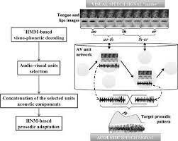

Figure: 14 overview of the segmental approach for a silent vocoder driven by video-only speech data

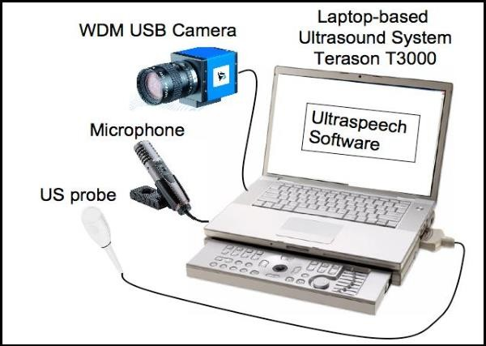

Figure: 15 shows a typical ultrasound SSI system

## ELECTROMYOGRAPHY

* + Electromyography (EMG) is a technique for evaluating and recording the electrical activity produced by skeletal muscles.
  + EMG is performed using an instrument called an electromyography, to produce a record called an electromyogram. An electromyograph detects the electrical potential generated by muscle cells when these cells are electrically or neurologically activated.
  + The signals can be analyzed to detect medical abnormalities, activation level, recruitment order or to analyze the biomechanics of human or animal movement
  + The Silent Sound Technology uses electromyography, monitoring tiny muscular movements that occur when we speak.
  + Monitored signals are converted into electrical pulses that can then be turned into speech, without a sound uttered.
  + Electromyography (EMG) is a technique for evaluating and recording the electrical activity produced by skeletal muscles.
  + An electromyography detects the electrical potential generated by muscle cells, when these cells are electrically or neurologically activated.

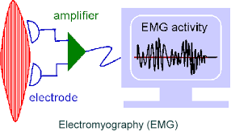

Figure 16 :Electromorphography signal generation

## ELECTRICAL CHARSTICSRACTE

* + The electrical source is the muscle membrane potential of about -90 mV. Measured EMG potentials range between less than 50 μV and up to 20 to 30 mV, depending on the muscle under observation.
  + Typical repetition rate of muscle motor unit firing is about 7–20 Hz, depending on the size of the muscle (eye muscles versus seat (gluteal) muscles), previous axonal damage and other factors. Damage to motor units can be expected at ranges between 450 and 780 mV.

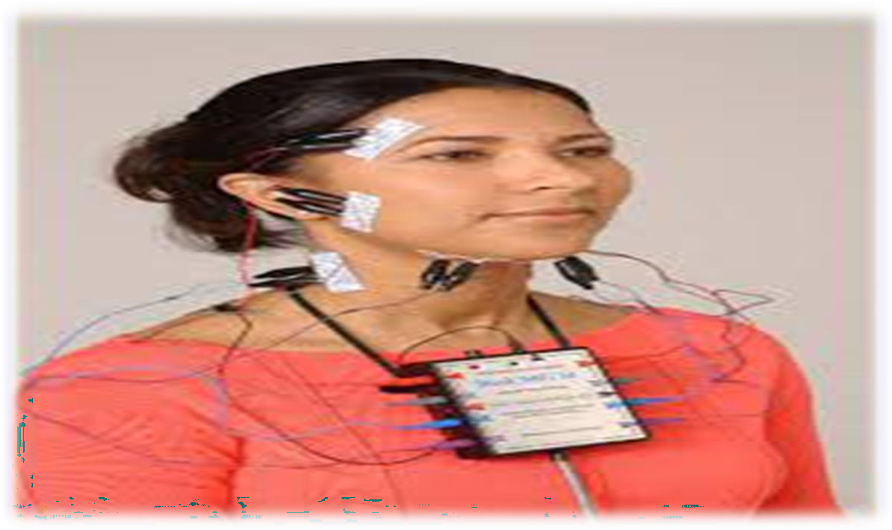

Figure : 17 Electromyographic sensors attached to the face

## PROCEDURE

* There are two kinds of EMG in widespread use: surface EMG and intramuscular (needle and fine-wire) EMG.
* To perform intramuscular EMG, a needle electrode or a needle containing two fine-wire electrodes is inserted through the skin into the muscle tissue.
* A trained professional (such as a neurologist, physiatrist, or physical therapist) observes the electrical activity while inserting the electrode.
* The insertion activity provides valuable information about the state of the muscle and its innervating nerve.
* Normal muscles at rest make certain, normal electrical signals when the needle is inserted into them. Then the electrical activity when the muscle is at rest is studied.
* Abnormal spontaneous activity might indicate some nerve and/or muscle damage.
* Then the patient is asked to contract the muscle smoothly. The shape, size, and frequency of the resulting motor unit potentials are judged.
* Then the electrode is retracted a few millimetres, and again the activity is analyzed until at least 10–20 units have been collected. Each electrode track gives only a very local picture of the activity of the whole muscle. Because skeletal muscles differ in the inner structure, the electrode has to be placed at various locations to obtain an accurate study.

There are two types of Electromyography (EMG)

1. **Surface Electromyography**: It consist of four different kind of transducers they are
   * Pressure sensor
   * Motion sensor
   * Vibration sensor
   * Electromagnetic sensor

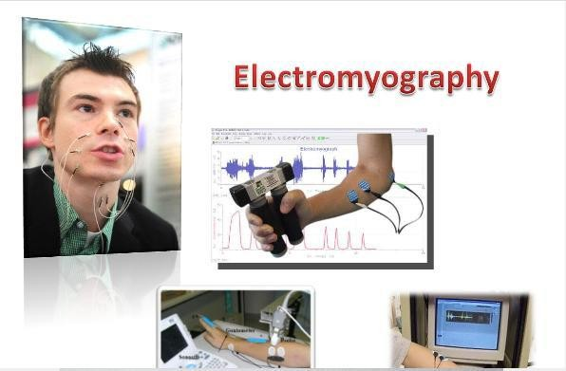

Figure 18 :Electromyography instruments

* Intramuscular EMG may be considered too invasive or unnecessary in some cases.
* Instead, a surface electrode may be used to monitor the general picture of muscle activation, as opposed to the activity of only a few fibres as observed using an intramuscular EMG.
* This technique is used in a number of settings; for example, in the physiotherapy clinic, muscle activation is monitored using surface EMG and patients have an auditory or visual stimulus to help them know when they are activating the muscle (biofeedback).

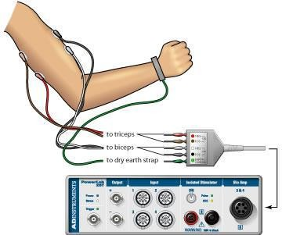

Figure 19: Interfacing with electromyography and body

* + A motor unit is defined as one motor neuron and all of the muscle fibers it innervates. When a motor unit fires, the impulse (called an action potential) is carried down the motor neuron to the muscle.
  + The area where the nerve contacts the muscle is called the neuromuscular junction, or the motor end plate.
  + After the action potential is transmitted across the neuromuscular junction, an action potential is elicited in all of the innervated muscle fibers of that particular motor unit.
  + The sum of all this electrical activity is known as a motor unit action potential (MUAP). This electrophysiological activity from multiple motor units is the signal typically evaluated during an EMG.
  + The composition of the motor unit, the number of muscle fibres per motor unit, the metabolic type of muscle fibres and many other factors affect the shape of the motor unit potentials in the my ogram.
  + Nerve conduction testing is also often done at the same time as an EMG to diagnose neurological diseases.
  + Some patients can find the procedure somewhat painful, whereas others experience only a small amount of discomfort when the needle is inserted. The muscle or muscles being tested may be slightly sore for a day or two after the procedure.

## Normal results

* Muscle tissue at rest is normally electrically inactive. After the electrical activity caused by the irritation of needle insertion subsides, the electromyograph should detect no abnormal spontaneous activity (i.e., a muscle at rest should be electrically silent, with the exception of the area of the neuromuscular junction, which is, under normal circumstances, very spontaneously active).
* When the muscle is voluntarily contracted, action potentials begin to appear. As the strength of the muscle contraction is increased, more and more muscle fibers produce action potentials. When the muscle is fully contracted, there should appear a disorderly

group of action potentials of varying rates and amplitudes (a complete recruitment and interference pattern).

## Abnormal results

* EMG is used to diagnose diseases that generally may be classified into one of the following categories: neuropathies, neuromuscular junction diseases and myopathies
* Neuropathic disease has the following defining EMG characteristics:
* An action potential amplitude that is twice normal due to the increased number of fibres per motor unit because of reinnervation of denervated fibres
* An increase in duration of the action potential
* A decrease in the number of motor units in the muscle (as found using motor unit number estimation techniques)

## Myopathic disease has these defining EMG characteristics:

* + A decrease in duration of the action potential
  + A reduction in the area to amplitude ratio of the action potential
  + A decrease in the number of motor units in the muscle (in extremely severe cases only)

Because of the individuality of each patient and disease, some of the characteristics may not appear in every case.

## EMG signal decomposition:

EMG signals are essentially made up of superimposed motor unit action potentials (MUAPs) from several motor units. For a thorough analysis, the measured EMG signals can be decomposed into their constituent MUAPs. MUAPs from different motor units tend to have different characteristic shapes, while MUAPs recorded by the same electrode from the same motor unit are typically similar.

Notably MUAP size and shape depend on where the electrode is located with respect to the fibers and so can appear to be different if the electrode moves position. EMG decomposition is non-trivial, although many methods have been proposed.

### Applications of EMG:

* + EMG signals are used in many clinical and biomedical applications.
  + EMG is used as a diagnostics tool for identifying neuromuscular diseases, assessing low-back pain, kinesiology, and disorders of motor control. EMG signals are also used as a control signal for prosthetic devices such as prosthetic hands, arms, and lower limbs.
  + EMG can be used to sense isometric muscular activity where no movement is produced.
  + This enables definition of a class of subtle motionless gestures to control interfaces without being noticed and without disrupting the surrounding environment.
  + These signals can be used to control a prosthesis or as a control signal for an electronic device such as a mobile phone or PDA.
  + EMG signals have been targeted as control for flight systems.
  + The Human Senses Group at the NASA Ames Research Center at Moffett Field, CA seeks to advance man-machine interfaces by directly connecting a person to a computer. In this project, an EMG signal is used to substitute for mechanical joysticks and keyboards.
  + EMG has also been used in research towards a "wearable cockpit," which employs EMG-based gestures to manipulate switches and control sticks necessary for flight in conjunction with a goggle-based display.

## Maximal voluntary contraction

* + One basic function of EMG is to see how well a muscle can be activated. The most common way that can be determined is by performing a maximal voluntary contraction (MVC) of the muscle that is being tested.
  + Muscle force, which is measured mechanically, typically correlates highly with measures of EMG activation of muscle. Most commonly this is assessed with surface electrodes, but it should be recognized that these typically record only from muscle fibers in close proximity to the surface
  + Several analytical methods for determining muscle activation are commonly used depending on the application. The use of mean EMG activation or the peak contraction value is a debated topic. Most studies commonly use the maximal voluntary contraction as a means of analyzing peak force and force generated by target muscles. According to the article "Peak and average rectified EMG measures: Which method of data reduction should be used for assessing core training exercises?" it was concluded that the “average rectified EMG data (ARV) is significantly less variable when measuring the muscle activity of the core

musculature compared to the peak EMG variable.” Therefore, these researchers would suggest that “ARV EMG data should be recorded alongside the peak EMG measure when assessing core exercises.” Providing the reader with both sets of data would result in enhanced validity of the study and potentially eradicate the contradictions within the research.

### Other measurements

* + EMG can also be used for indicating the amount of fatigue in a muscle. The following changes in the EMG signal can signify muscle fatigue: an increase in the mean absolute value of the signal, increase in the amplitude and duration of the muscle action potential and an overall shift to lower frequencies. Monitoring the changes of different frequency changes the most common way of using EMG to

determine levels of fatigue. The lower conduction velocities enable the slower motor neurons to remain active.

* + A motor unit is defined as one motor neuron and all of the muscle fibers it innervates. When a motor unit fires, the impulse (called an action potential) is carried down the motor neuron to the muscle. The area where the nerve contacts the muscle is called the neuromuscular junction, or the motor end plate. After the action potential is transmitted across the neuromuscular junction, an action

potential is elicited in all of the innervated muscle fibers of that particular motor unit. The sum of all this electrical activity is known as a motor unit action potential (MUAP). This electrophysiologic activity from multiple motor units is the signal typically evaluated during an EMG. The composition of the motor unit, the number of muscle fibres per motor unit, the metabolic type of muscle fibres and many other factors affect the shape of the motor unit potentials in the myogram.

* + Nerve conduction testing is also often done at the same time as an EMG to diagnose neurological diseases.
  + Some patients can find the procedure somewhat painful, whereas others experience only a small amount of discomfort when the needle is inserted. The muscle or muscles being tested may be slightly sore for a day or two after the procedure.

## FEATURES OF SILENT SOUND TECHNOLOGY:

Some of the features of silent sound technology are

* Native speakers can silently utter a sentence in their language, and the receivers can hear the translated sentence in their language. It appears as if the native speaker produced speech in a foreign language. The translation technology works for languages like English, French and German, except Chinese, where different tones can hold many different meanings.
* Allow people to make silent calls without bothering others.
* The Technology opens up a host of application such as mentioned below
* Helping people who have lost their voice due to illness or accident.
* Telling a trusted friend your PIN number over the phone without anyone eavesdropping — assuming no lip-readers are around.
* Silent Sound Techniques is applied in Military for communicating secret/confidential matters to others.

# APPLICATIONS

### The Technology opens up a host of application such as mentioned below:

* Helping people who have lost their voice due to illness or accident.
* Telling a trusted friend your PIN number over the phone without anyone eavesdropping — assuming no lip-readers are around.
* Silent Sound Techniques is applied in Military for communicating secret/confidential matters to others.
* Native speakers can silently utter a sentence in their language, and the receivers can hear the translated sentence in their language. It appears as if the native speaker produced speech in a foreign language. The translation technology works for languages like English, French and German, except Chinese, where different tones can hold many different meanings.
* Allow people to make silent calls without bothering others.

# Advantage

* Voice and has been rendered mute due to accident.
* At public crowded places like in market, bus, train, malls, theater etc.
* Very good technology for noise cancellation technique.
* Helps in making phone calls in noisy environment.
* Very useful for sharing confidential information like secret PIN number on phone at public place.
* Very useful for astronaut.

# Disadvantage

* Translation into majority of languages but for languages such as Chinese different tone holds different meaning, facial movements being the same. Hence this technology is difficult to apply in such situations.
* Even differentiating between people and emotions cannot be done. This means you will always feel you are talking to a robot.
* From security point of view recognising who you are talking to gets complicated.
* This device presently needs nine leads to be attached to our face which is quite impractical to make it usable.
* This technology will be very costly for a common man.

# RESEARCH AND FUTURE PROSPECT

* Silent sound technology gives way to a bright future to speech recognition technology from simple voice commands to memorandum dictated over the phone all this is fairly possible in noisy public places.
* Without having electrodes hanging all around your face, these electrodes will be incorporated into cell phones.•
* It may have features like lip reading based on image recognition processing rather than electromyography.
* Nano technology will be a mentionable step towards making the device handy.
* With all of the millions of phones in circulation, there is great potential for increasing earnings by saving 'lost calls' - telephone calls that go unanswered or uninitiated because the user is in a situation in which he or she cannot speak - not just in business meetings, but everyday situations. According to research, these 'lost calls' are worth $20 billion per year worldwide. For the cellular operator, these are potential earnings that are

currently being left on the table. When these 'lost calls' become answerable, and can be conducted without making a sound, there is a tremendous potential for increased profits. Now the research is going on technology that can be used in Office Environment too.

* In the feature the silent sound technology will be incorporate into mobile phone or headset which headset would decipher the movement of the lips and jaws and received electrical impulse which will be convert into sound signal before transmitted.

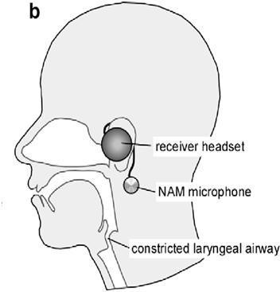

Figure 20 : silent sound technology develop in headset or cell phone

# CONCLUSION

* Thus Silent Sound Technology, one of the recent trends in the field of information technology implements ”Talking without Talking”.
* It will be one of the innovation and useful technology and in mere future this technology will be use in our day to day life.

‘Silent Sound’ technology aims to notice every movements of the lips and transform them into sounds, which could help people who lose voices to speak, and allow people to make silent calls without bothering others.

Rather than making any sounds, your handset would decipher the movements your mouth makes by measuring muscle activity, then convert this into speech that the person on the other end of the call can hear. So, basically, it reads your lips.

# REFERENCES

## Books

* + Denby B, Schultz T, Honda K, Hueber T, Gilbert J.M., Brumberg J.S. (2010). *Silent speech interfaces. Speech Communication*

Web :-

* + <https://www.ijsr.net/archive/v6i4/16041706.pdf>
  + <https://studymafia.org/silent-sound-technology-seminar-ppt-and-pdf-report/>
  + <https://studylib.net/doc/25548833/silent-sound-technology-ppt>
  + <https://en.wikipedia.org/wiki/Electromyography>